SPRING CAMPING AND BRIDGING CEREMONY
BW Wells Camp Ground
1630 Bent Rd. Wake Forest, NC 27587

Meals
The pack provides the breakfast-lunch-dinner meals on Saturday and breakfast Sunday morning. No mess kits required due to COVID procedures. Adult Volunteers are always needed.
Service Project
The Cubs will be working Saturday morning on a service project to support the park. The details will be shared at the opening flag raising.
Activities
- Flag Pole Construction
- Compass Course
- Star Gazing (weather permitting)
- Fishing Contest
- Hiking
- Field Day Activities/Games
- Den Activities
- Recognition and Bridging Ceremony
- DEN Level Campfire Program (Skits & Smores)

Campsite Assignments
Site 8 Bears
Site 9 Webelos
Site 10 Lions and Tigers
Site 11 Wolves

Campsites are NOT drive-up sites
so bring your wagons!!!

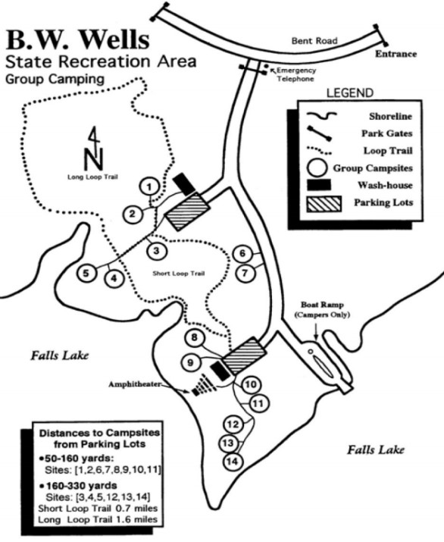

FRIDAY Uniform Notes
3:00pm Arrive and Set Up B Dinner on your own
5:00pm Flag Raising (All Hands) B
7:00pm Leaders Meeting Amphitheater
8:00pm Den Campfires B In your campsite
9:00pm Star Gazing B Activity Field
10:00pm Lights Out

SATURDAY
7:00am Reveille
7:45am Flag Raising (AOL) A WELCOME
8:00am Breakfast A Adults Only
9:00am Den Activities B B.W. Wells
9:00am Service Shift 1 B 9am-10:30
10:00am Service Shift 2 B 10am-11:30
12:00pm Lunch-AOL B Adults Only
1:00pm Den Activity B B.W. Wells
1:00pm Field Day Activities B Activity Field

5:15pm Flag Lowering (Wolves) A Announcements
5:30pm Dinner A Adults Only
Bridging and Awards A Amphitheater
6:30pm Den Time B B.W. Wells
8:00pm Den Campfire & Skits B Campsite 9/Webelos
1000 Lights Out

SUNDAY
7:00am Reveille
7:45am Flag Raising (Tigers) A Activity Field
8:00am Breakfast A Adults Only
9:00am Flag Lowering (Webelos) A Activity Field
10:00am Camp Cleanup

